Concurrency Control Manager

🔁 What Is a Concurrency Control Manager in a DBMS?
# Source: AI Source: Provided by: [Data Path: Persons Table -> ID Column: 1, Name_En Column: Motasem Essam] -> From: [ChatGPT] on [6/10/2026]
The Concurrency Control Manager is a core component of a Database Management System (DBMS) that ensures correct and safe access to data when multiple users or processes access the database at the same time.
Its job is to prevent conflicts, inconsistencies, and data corruption caused by simultaneous transactions — while still allowing as much parallelism as possible for performance.

🔍 Why Is It Needed?
# Source: AI Source: Provided by: [Data Path: Persons Table -> ID Column: 1, Name_En Column: Motasem Essam] -> From: [ChatGPT] on [6/10/2026]
Imagine two users running transactions at the same time:
- User A is updating a row
- User B is reading or updating the same row
If not controlled, this can cause:
- 🔄 Lost updates
- 👻 Phantom reads
- 🧼 Dirty reads
- ⚖️ Inconsistent data

🧩 Key Responsibilities
# Source: AI Source: Provided by: [Data Path: Persons Table -> ID Column: 1, Name_En Column: Motasem Essam] -> From: [ChatGPT] on [6/10/2026]
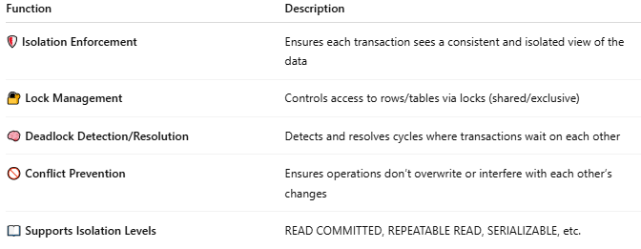
Function | Description
🛡️ Isolation Enforcement | Ensures each transaction sees a consistent and isolated view of the data
🔐 Lock Management | Controls access to rows/tables via locks (shared/exclusive)
🧠 Deadlock Detection/Resolution | Detects and resolves cycles where transactions wait on each other
🚫 Conflict Prevention | Ensures operations don’t overwrite or interfere with each other’s changes
📖 Supports Isolation Levels | READ COMMITTED, REPEATABLE READ, SERIALIZABLE, etc.

🔧 Techniques Used
# Source: AI Source: Provided by: [Data Path: Persons Table -> ID Column: 1, Name_En Column: Motasem Essam] -> From: [ChatGPT] on [6/10/2026]
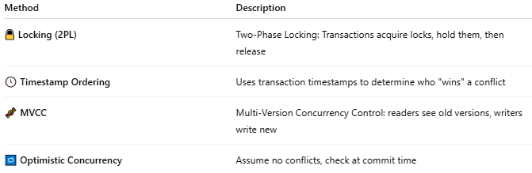
Method | Description
🔒 Locking (2PL) | Two-Phase Locking: Transactions acquire locks, hold them, then release
🕓 Timestamp Ordering | Uses transaction timestamps to determine who "wins" a conflict
🧬 MVCC | Multi-Version Concurrency Control: readers see old versions, writers write new
🔁 Optimistic Concurrency | Assume no conflicts, check at commit time

🛠️ In Popular DBMSs
# Source: AI Source: Provided by: [Data Path: Persons Table -> ID Column: 1, Name_En Column: Motasem Essam] -> From: [ChatGPT] on [6/10/2026]
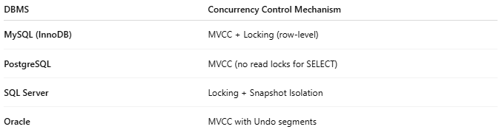
DBMS | Concurrency Control Mechanism
MySQL (InnoDB) | MVCC + Locking (row-level)
PostgreSQL | MVCC (no read locks for SELECT)
SQL Server | Locking + Snapshot Isolation
Oracle | MVCC with Undo segments

🧪 Example: Lost Update Without Concurrency Control
# Source: AI Source: Provided by: [Data Path: Persons Table -> ID Column: 1, Name_En Column: Motasem Essam] -> From: [ChatGPT] on [6/10/2026]
Two users run:
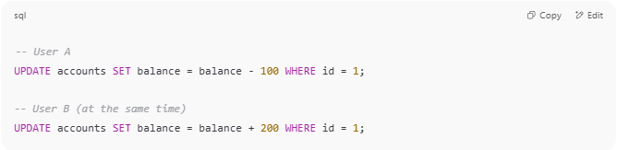
-- User A
UPDATE accounts SET balance = balance - 100 WHERE id = 1;

-- User B (at the same time)
UPDATE accounts SET balance = balance + 200 WHERE id = 1;

Without control, one update might overwrite the other.
The Concurrency Control Manager ensures that these updates are either serialized correctly or one waits or rolls back.

📏 Isolation Levels (Controlled by CCM)
# Source: AI Source: Provided by: [Data Path: Persons Table -> ID Column: 1, Name_En Column: Motasem Essam] -> From: [ChatGPT] on [6/10/2026]
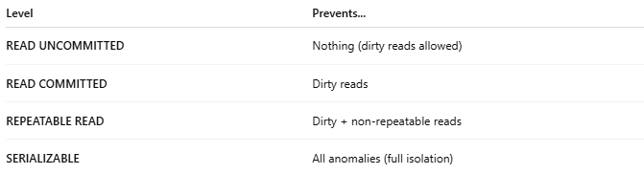
Level | Prevents...
READ UNCOMMITTED | Nothing (dirty reads allowed)
READ COMMITTED | Dirty reads
REPEATABLE READ | Dirty + non-repeatable reads
SERIALIZABLE | All anomalies (full isolation)

📌 Summary
# Source: AI Source: Provided by: [Data Path: Persons Table -> ID Column: 1, Name_En Column: Motasem Essam] -> From: [ChatGPT] on [6/10/2026]
The Concurrency Control Manager ensures safe, correct, and isolated access to data by multiple users at once — maintaining data integrity and transaction reliability in a multi-user environment.

